**PREGO Displays**

**Human Factors Comments – Jan 6, 2016**

**General Suggestions:**

1. It may make sense to have the Dashboard icons be part of the standard template for any screen that is chosen. This way, the user could see the status of the system regardless of what screen he was on. Perhaps it could be made smaller for the non-dashboard screens, but still large enough to be visible at the top. For example, see the header below that incorporates the dashboard icons (this portrays a rough suggestion what could be done):

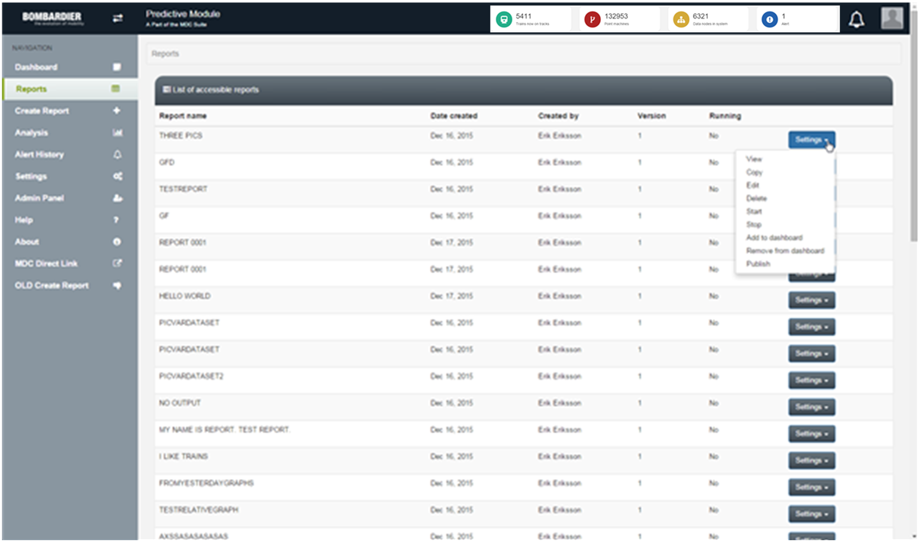

1. Provide sorting and filtering options for any list data provided. Also allow width adjustment of columns.
2. The list was so long, the scrollbar was required to get to the bottom – However, The paging option in the bottom lower right says there is only one page. Since the scrollbar was needed, to me this means there is >1 page.

**Dashboard**

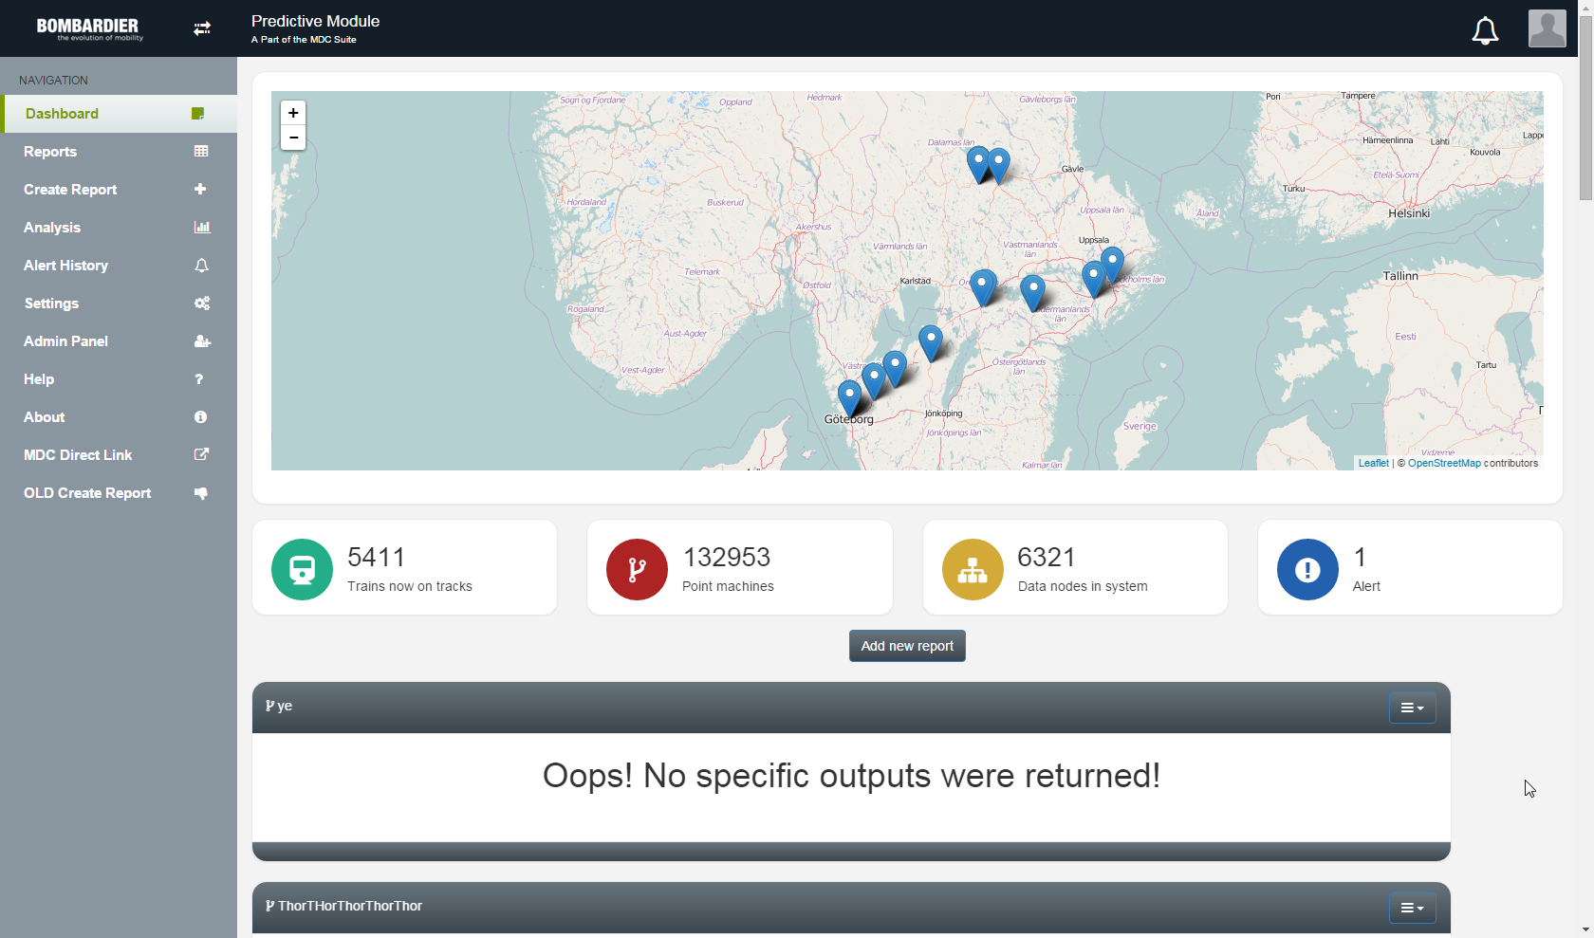

Suggestions:

1. Suggest that the icons (Train..., Points…, Data nodes… and Alert) be moved to the top of the screen. The map would move to a central location and the tables would be last.

**Reports:**

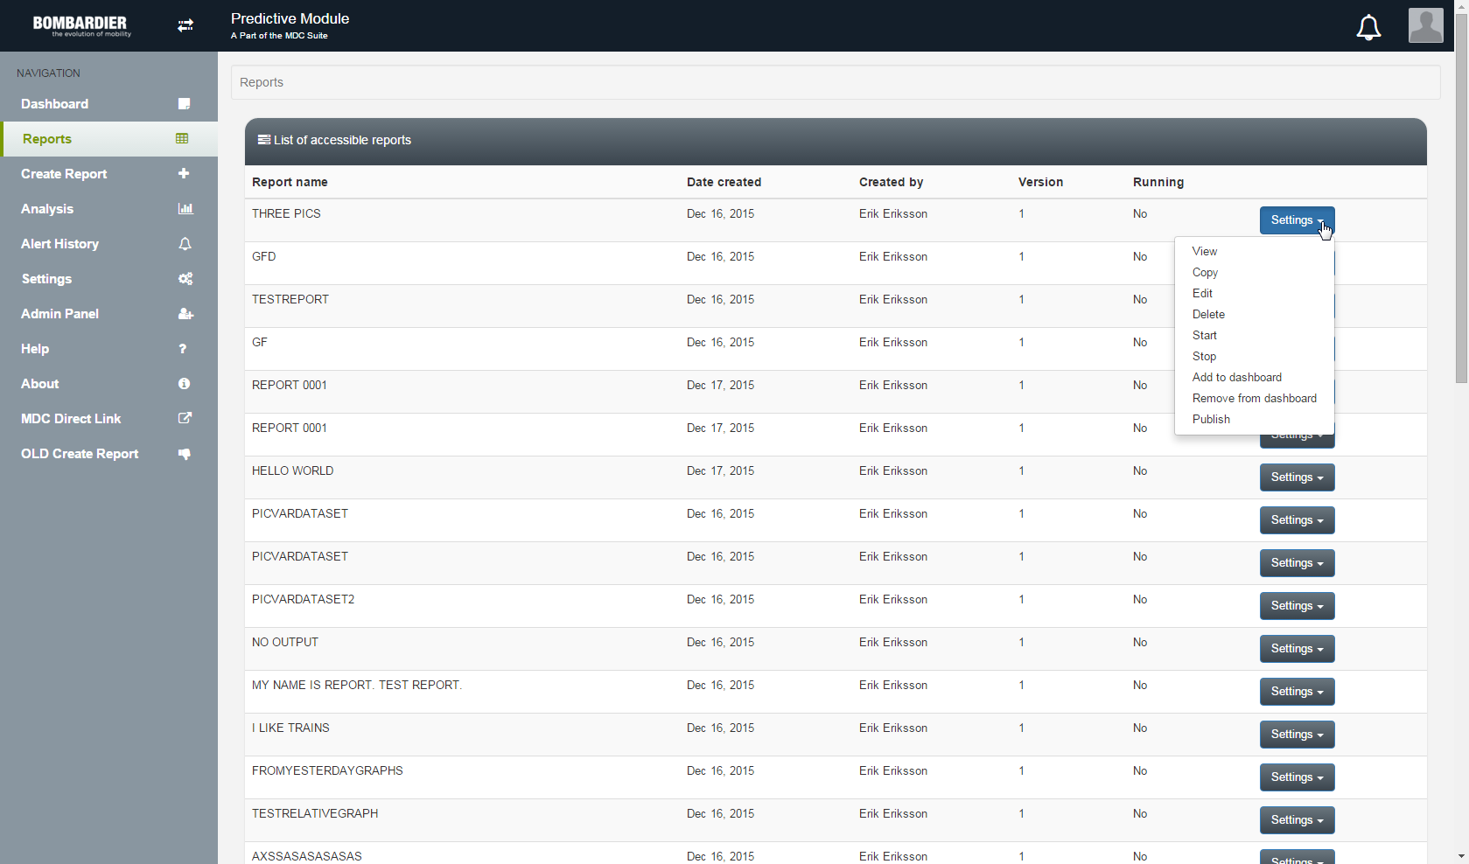

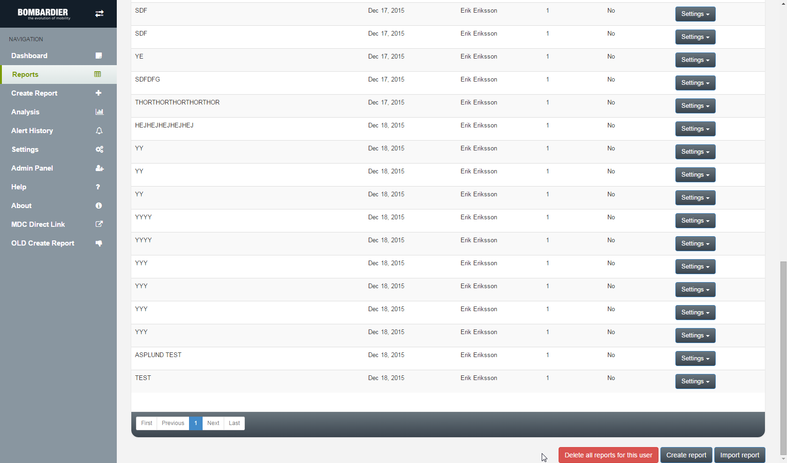

Suggestions:

1. In the navigation bar to the left, since the “Create Report”, is a suboption of the “Reports” menu, it would be best to indent it in the menu to more clearly show the fact that it is a suboption
2. Provide sorting and filtering options for list data provided. Allow width adjustment of columns.
3. The list was so long, the scrollbar was required to get to the bottom – However, The paging option in the bottom lower right says there is only one page. Since the scrollbar was needed, to me this means there is >1 page.

**Create Report:**

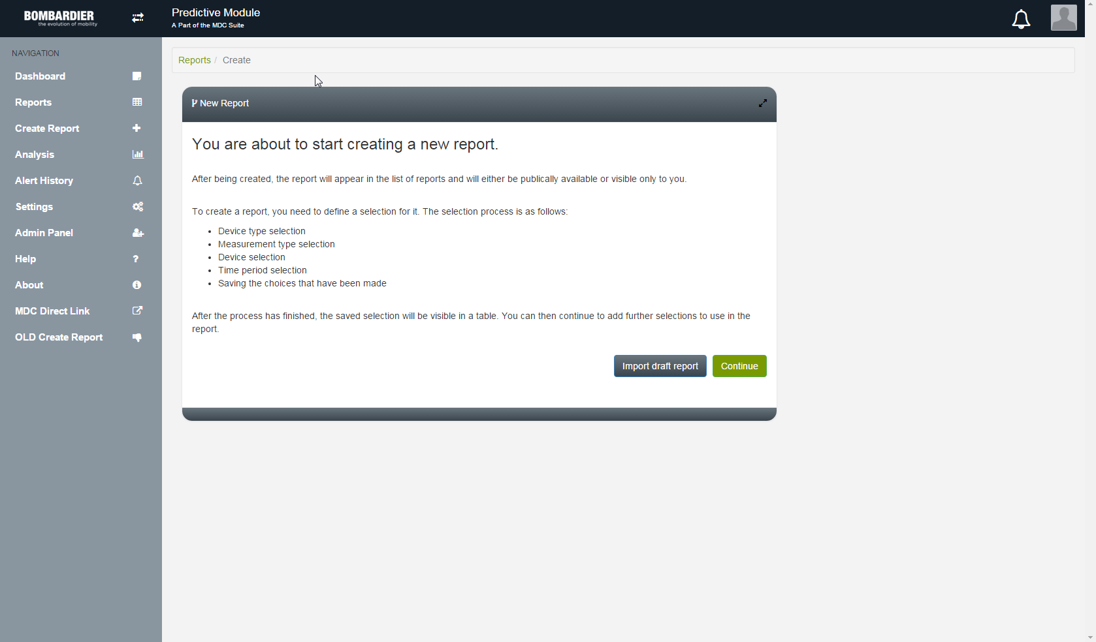

Suggestions:

1. This screen does not show which option is selected in the navigation bar to the left. “Create Report” should still be highlighted to show that this is the current selection
2. Since the “Create Report”, is a suboption of the “Reports” menu, it would be best to indent it in the menu to more clearly show the fact that it is a suboption

**Use Template:**

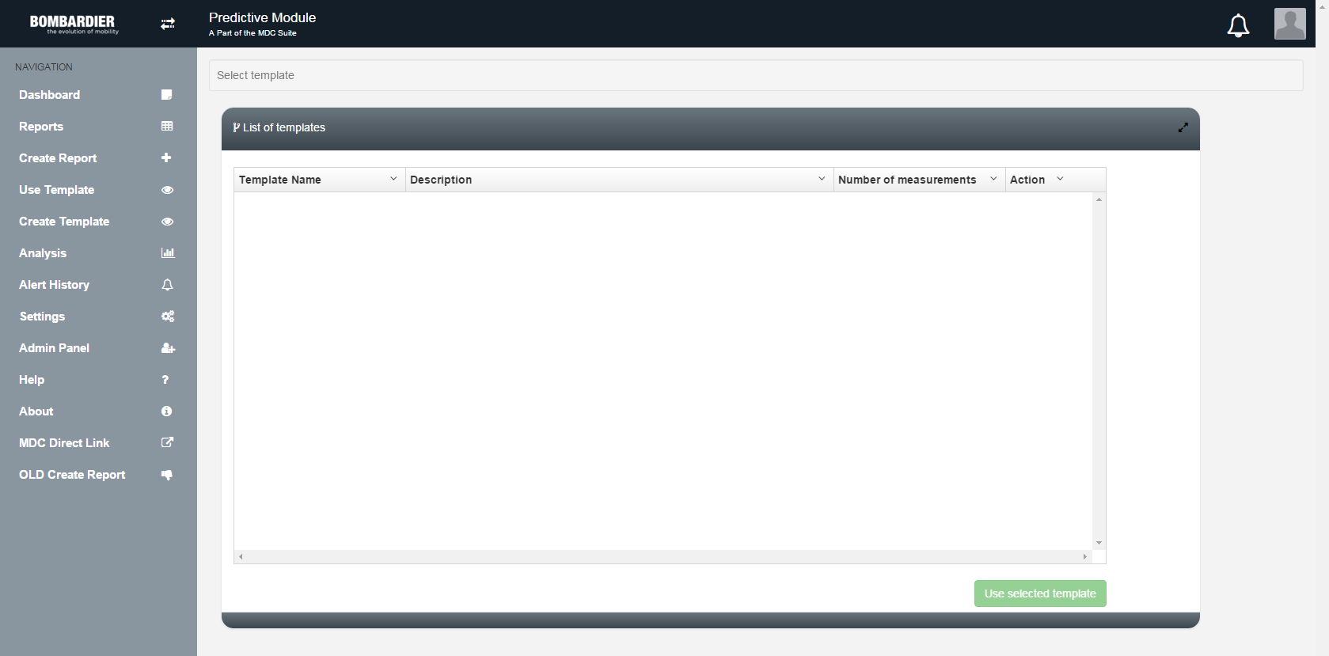

No comments.

**Analysis:**

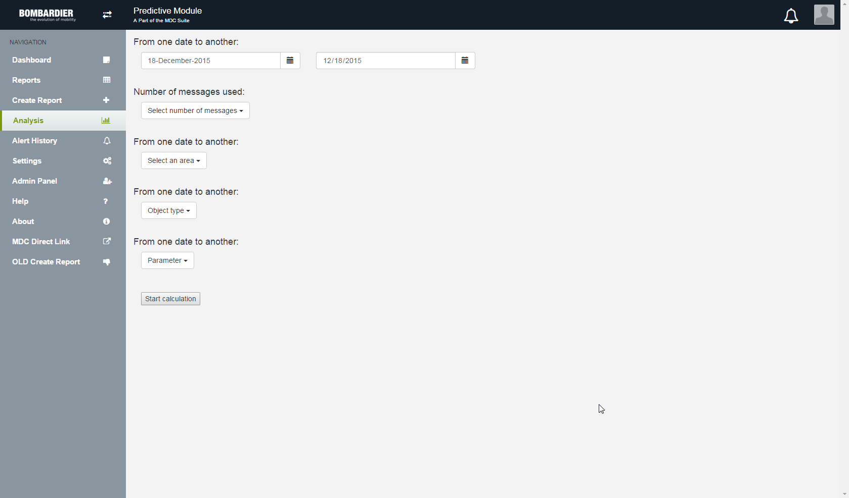

Suggestions:

1. “From one date to another” is used as the preface to the “date”, “type” and “parameter” selections. Change each statement to the following, respectively:
   1. Area selection:
   2. Object type selection:
   3. Parameter selection:

**Alert History:**

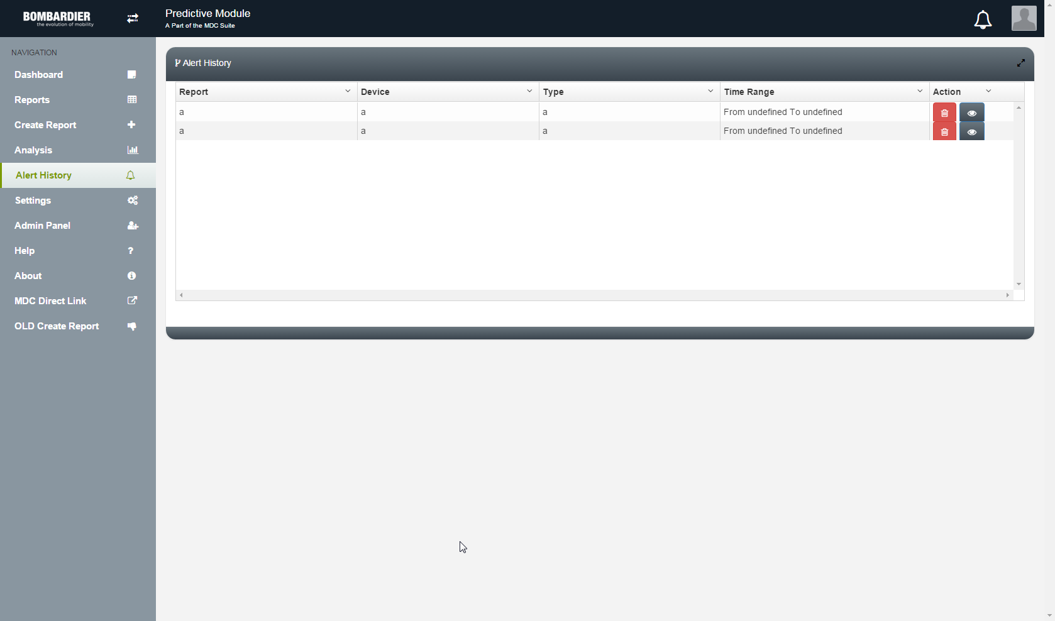

Comments:

1. Will the Alert (bell) icon in the upper right corner be filled with a differentiating color when there are active alerts?
2. Are there different priorities that can be defined for alerts? If so, these priorities should be visible in the Alert History list.

**Settings:**

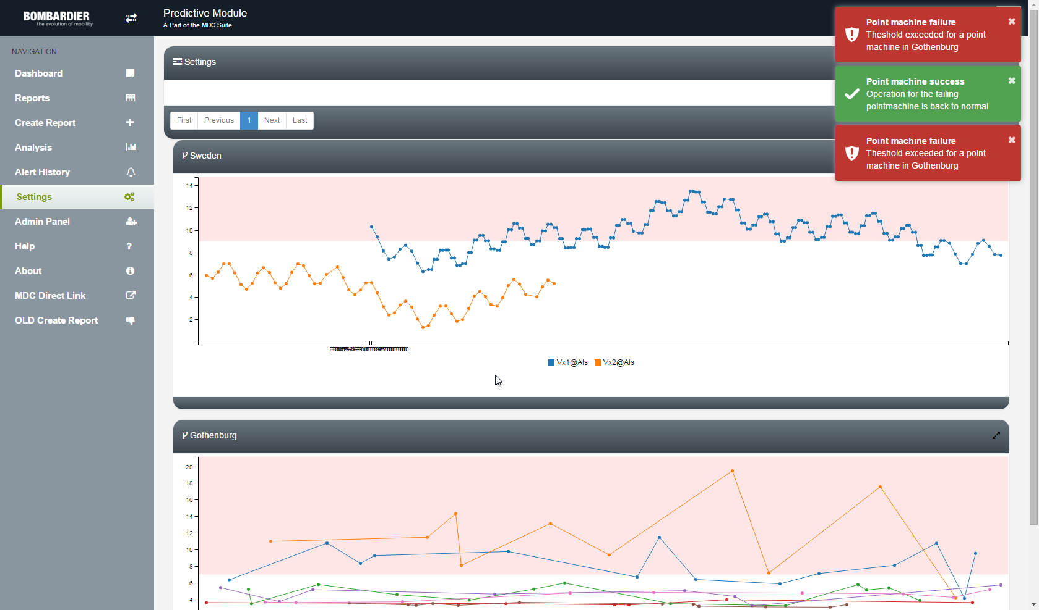

Suggestions:

1. The pop-up alarm boxes in the upper right are helpful when there are only a handful of alerts, but what happens if there are more than a few (6, 12, 50, …)? Will clicking on each of the alerts navigate the user to the “Alert History” screen?
2. Increase the size of the location tile (e.g. “Sweden”, “Gothenburg”) and corresponding icon in the header bar for each chart.
3. The X-axis labels are illegible. Suggest make the orient the time and date in an “over/under” fashion to make it easier to interpret:

2016-01-06  
05:20.108

1. Provide a Key for charts that have more than one variable plot.